

PROJECT REPORT ON
BROWSER HISTORY
SIMULATOR

Subject: Data Structures - Lab Submitted By:
Name | Branch | PRN
M.Bhanurekha | CSE | 25070721035

INDEX

- Acknowledgement
- Abstract and Introduction
- Methodology
- Theory
- Applications and Future Scope

ACKNOWLEDGEMENT
I would like to express my sincere gratitude and heartfelt thanks to everyone who supported and guided me in successfully completing my project titled “BROWSER HISTORY SIMULATOR.”
First and foremost, I would like to thank Almighty God for giving me the strength, knowledge, patience, and confidence to complete this project successfully.
I would like to express my deep gratitude to my respected Principal and Head of the Department for providing me with the necessary facilities, encouragement, and support throughout the development of this project.
I am extremely thankful to my project guide and faculty members for their valuable guidance, continuous encouragement, constructive suggestions, and support. Their knowledge and guidance helped me understand the concepts involved in the project and complete it in an effective manner.
This project, Browser History Simulator, helped me gain a better understanding of how web browsers maintain and manage browsing history. Through this project, I learned about important browser navigation operations such as Visit, Back, Forward, and Clear History. I also gained practical knowledge of data structures, particularly the Stack concept, and understood how it can be used to implement browser navigation functionality.
While developing this project, I gained valuable experience in logical thinking, problem-solving, programming concepts, and application development. It also helped me understand how real-world applications use data structures to manage user activities efficiently. This project improved my technical skills and gave me an opportunity to apply the theoretical knowledge gained in the classroom to a practical implementation.
Finally, I would like to extend my heartfelt thanks to my parents and family members for their constant love, patience, motivation, and support throughout my academic journey. Without their encouragement and blessings, completing this project would not have been possible.
I consider this project a valuable learning experience that has enhanced my technical knowledge and practical understanding of computer science concepts. I sincerely thank everyone who directly or indirectly contributed to the successful completion of this project.

ABSTRACT AND INTRODUCTION
The Browser History Simulator is a software-based project designed to demonstrate the working and functionality of browser history management in a simple and interactive way. In today's digital world, web browsers have become an essential part of our daily lives. People use web browsers to search for information, visit websites, read articles, watch videos, communicate with others, and perform various online activities. While browsing the internet, users frequently move from one webpage to another. To make navigation easier and more convenient, web browsers provide important features such as Back, Forward, and browsing history.
The Browser History Simulator is developed to demonstrate how a web browser manages the sequence of webpages visited by a user. It provides a simple simulation of browser navigation and helps users understand how browsing history is maintained, updated, and managed. The main objective of this project is to understand the practical application of data structures, especially the Stack data structure, in browser history management.
A stack is a linear data structure that follows the principle of LIFO (Last In, First Out), which means the last element inserted is the first element removed. This concept is useful in implementing browser navigation. In a typical browser history implementation, two stacks can be used to manage backward and forward navigation. One stack maintains the previously visited webpages, while the other stores the webpages that can be accessed using the Forward operation.
Whenever a user visits a new webpage, its name or URL is stored in the browsing history. When the user clicks the Back button, the simulator allows them to return to the previously visited webpage. Similarly, the Forward button helps users move to the next webpage after navigating backward. If the user visits a new webpage after clicking the Back button, the forward history is cleared because a new navigation path has been created. This behavior is similar to the navigation functionality available in modern web browsers.

Overall, this project connects theoretical concepts with practical implementation and explains the importance of data structures in software development. It serves as an educational tool for understanding browser navigation, history management, and the application of stack data structures in everyday technology. Through the development of this project, we gain valuable technical knowledge and a better understanding of how browser history management functions in real-world web browsers.

METHODOLOGY

- Requirement Analysis: Identifies the basic requirements, including Visit, Back, Forward, and Clear History operations.
- System Design: Designs the structure and user interface of the Browser History Simulator.
- Data Structure Implementation: Uses the Stack data structure (LIFO) to manage webpage navigation and browsing history.
- Visit Operation: Allows users to enter and visit new webpages while updating the browsing history.
- Back Operation: Allows users to return to the previously visited webpage.
- Forward Operation: Allows users to move forward to the next webpage in the browsing history.
- Clear History Operation: Removes all stored browsing history and resets the simulator.
- Display History: Displays the list of visited webpages and highlights the currently active webpage.

- Testing and Verification: Tests all navigation operations to ensure that the simulator works correctly.

- Final Implementation: Combines all features into a simple and interactive Browser History Simulator.

THEORY

The Browser History Simulator is a software application designed to demonstrate how web browsers maintain and manage the history of visited webpages. It allows users to navigate between different webpages using basic browser operations such as Visit, Back, Forward, and Clear History. The main concept behind this project is the Stack data structure, which follows the LIFO (Last In, First Out) principle.

In a web browser, whenever a user visits a new webpage, the details of that webpage are stored in the browsing history. When the user clicks the Back button, the browser takes them to the previously visited webpage. Similarly, the Forward button allows users to return to the next webpage after moving backward.

The simulator uses two stacks to manage backward and forward navigation. The Back Stack stores previously visited webpages, while the Forward Stack stores webpages that can be accessed by moving forward. The current webpage represents the page currently displayed to the user.

When a new webpage is visited after moving backward, the forward history is cleared because a new browsing path is created. The Clear History operation removes the stored webpage records and resets the simulator.

This project helps students understand the practical application of data structures in real-world applications. It also improves programming knowledge, logical thinking, problem-solving skills, and understanding of browser navigation mechanisms.

- Stack Data Structure: The project uses the Stack data structure, which follows the LIFO (Last In, First Out) principle to manage browsing history.

- Visit Operation: Allows users to enter a webpage name or URL and visit a new webpage. The newly visited webpage becomes the current page.

- Back Navigation: Allows users to move to the previously visited webpage by retrieving the previous page from the browsing history.

- Forward Navigation: Helps users move forward to the next webpage after using the Back operation.

- Clear History: Removes all previously stored browsing history and resets the simulator to its initial state.

- Display History: Displays the list of webpages visited by the user and identifies the currently active webpage.

- History Management: Maintains the sequence of visited webpages and updates the history whenever a new webpage is opened.

- Two Stack Concept: Uses Back Stack and Forward Stack to manage backward and forward navigation efficiently.

- User-Friendly Interface: Provides simple and interactive controls that allow users to perform browser operations easily.

- Forward History Management: Clears the forward history whenever a user visits a new webpage after moving backward.

- Error Handling: Prevents invalid navigation operations, such as moving backward when no previous webpage is available.

- Practical Application: Demonstrates how stack operations are used in real-world applications such as web browsers.
.

- Efficient Navigation: Makes it easier to move between previously visited

- Learning Outcome: Helps students understand data structures, programming
concepts, logical operations, and application development.

ADVANTAGES
  - Easy to understand and operate.
  - Demonstrates practical stack implementation.
  - Provides simple browser navigation.
  - Helps manage webpage history efficiently.
  - Improves programming and problem-solving skills.
  - Useful for learning data structures and algorithms.

APPLICATIONS
  - Understanding browser navigation systems.
  - Learning stack data structures.
  - Demonstrating Back and Forward operations.
  - Understanding history management in web browsers.
  - Educational purposes and programming practice.

APPLICATIONS AND FUTURE SCOPE

Applications
- Web Browser Navigation: Helps users understand Back and Forward navigation.
- Educational Purpose: Useful for learning stack data structures and their applications.
- History Management: Demonstrates how visited webpages are stored and managed.
- Programming Practice: Improves coding skills and logical thinking.
- Algorithm Demonstration: Explains the LIFO (Last In, First Out) principle.

Future Scope
  - Bookmark Feature: Allow users to save their favourite webpages.
  - Multiple Tabs: Support opening and managing multiple browser tabs.
  - History Storage: Store browsing history permanently using a database.
  - Search History: Allow users to search previously visited webpages.
  - Improved Interface: Develop a more attractive and user-friendly design.

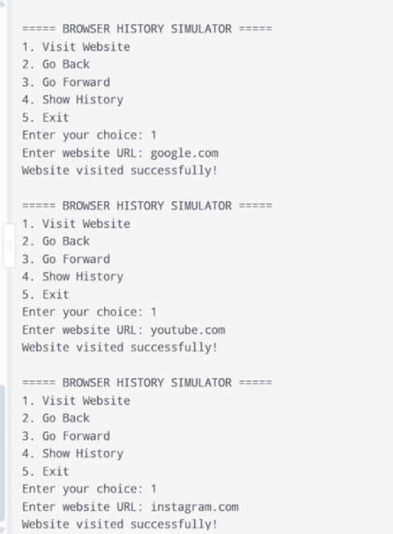

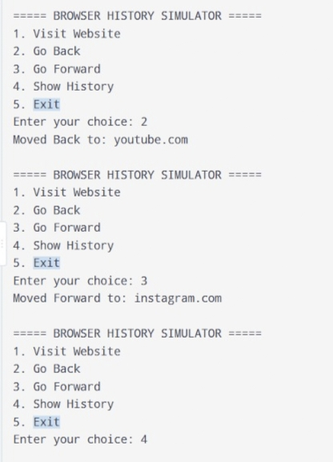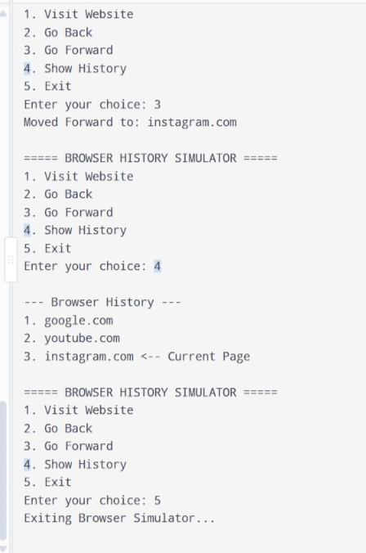

- Try visiting another website.
- Use the Back button to revisit the previous page.
- Use the Forward button to return to the next page.
- Search for a website in browsing history.
- Clear browsing history when needed.
- Explore how browser navigation work.

